Financial Fraud Dataset Analysis
In this project, we are going to analyze the data that we have got from financial banks of to know they way to analyze the performance and also we are going to help them in creating a model which would help them to predict any fraud possibilities in future based on the pattern that we find in existing data.
We have four tables with us and they are:
1. Card Details:
This table contains the details of card, their type, network they belongs to and also the customer_Id who uses the card.
2. Customer_Data:
It contains the details of the customer, their age, gender, martial status, occupation and their located city and state.
3.Merchant_Table:
It contains the detail of merchant account such as their name, category and the location it located.
4. Transaction Details:
It contains the transactions that have happened between customer and merchants. The additional details like payment type, transaction type and Transaction status also helps us in validating the quality of data.

With basic details I have observed, it is found that Transaction details acts as central table, around which other tables like Card, Customer Data and Merchant Tables were present.
In terms, we can clearly see it as star schema, which will help us to efficiently solve the problems that were come forward.
Next step, we have analyzed the tables for any null or duplicate values and it is made sure that no null values present and through unique ids present in the column we have verified and confirmed that there are multiple transactions happened between customer and merchant on different time intervals exist.
Lets analyze each tables in detail:
- Card Data
- In card Data table, there are four types of card type available are:
- Silver
- Classic
- Gold
- Platinum
- Similarly, when we analyzed the list of card network available in same way we found that:
- RuPay
- Mastercard
- American Express
- Visa
These are all the details that we have got when we analyzed. Now when we looked into the combination (Card_Type+Card_Network) we have found that:
- There are 16 combinations(4x4) present as we expected at start.
And other details that we have found in cards Table is:
- There are two types of card status available (Active/Expired).
- Two types of Card_Mode(Physical/Virtual).
- Contactless – 1/0 (Yes/NO)
- The cards were issued between 2018(20th July) to 2026(19th July).
- Similarly, the expiry date exists between 2023(20th July) to 2031(19th July).
- Through the observation, we can confirm that the tenure period for a card is 5 years.
And we tend to find the minimum and maximum credit limit available for each card and it is listed as follows:

Card_type | Card_network | Min_Amount | Max_Amount
Gold | American Express | ₹300009/- | ₹699693/-
Silver | Mastercard | ₹150123/- | ₹299871/-
Classic | American Express | ₹50143/- | ₹149946/-
Platinum | Mastercard | ₹700054/- | ₹1499927/-
Platinum | RuPay | ₹700319/- | ₹1499718/-
Silver | RuPay | ₹150023/- | ₹299882/-
Classic | Visa | ₹50075/- | ₹149989/-
Gold | Visa | ₹300023/- | ₹699911/-
Gold | Mastercard | ₹300131/- | ₹699897/-
Silver | American Express | ₹150111/- | ₹299984/-
Platinum | American Express | ₹701096/- | ₹1499322/-
Gold | RuPay | ₹300068/- | ₹699787/-
Classic | Mastercard | ₹50002/- | ₹149998/-
Platinum | Visa | ₹700118/- | ₹1499653/-
Silver | Visa | ₹150138/- | ₹300000/-
Classic | RuPay | ₹50074/- | ₹149994/-

2.Customer Details:
This table contains the details of customer present across country. The notable segments include age, gender marital status, occupation, state and country.
The Key insights that we have found are:
- This table contains the details of 25000 customers.
- Their age lies between 18 to 70.
- The four segments of customer present are Basic, Standard, Gold and Platinum.
- Account Type(Salary/Savings/Current/Student).
- The State and City that customer belongs to are:
State | City
Assam | Jorhat
Assam | Nagaon
Assam | Silchar
Assam | Dibrugarh
Assam | Guwahati
Bihar | Bhagalpur
Bihar | Muzaffarpur
Bihar | Purnia
Bihar | Gaya
Bihar | Patna
Gujarat | Vadodara
Gujarat | Bhavnagar
Gujarat | Jamnagar
Gujarat | Surat
Gujarat | Gandhinagar
Gujarat | Ahmedabad
Gujarat | Rajkot
Haryana | Palwal
Haryana | Gurugram
Haryana | Sohna
Haryana | HOdal
Haryana | Nuh
Haryana | Faridabad
Karnataka | Bengaluru
Karnataka | Hubballi-Dharwad
Karnataka | Mangaluru
Karnataka | Belagavi
Karnataka | Mysuru
Kerala | Thiruvananthapuram
Kerala | Kozhikode
Kerala | Kollam
Kerala | Thrissur
Kerala | Kochi
Madhya Pradesh | Indore
Madhya Pradesh | Bhopal
Madhya Pradesh | Gwalior
Madhya Pradesh | Ujjain
Madhya Pradesh | Jabalpur
Maharashtra | Mumbai
Maharashtra | Aurangabad
Maharashtra | KOlhapur
Maharashtra | Thane
Maharashtra | Nashik
Maharashtra | Pune
Maharashtra | Nagpur
Odisha | Rourkela
Odisha | Puri
Odisha | Sambalpur
Odisha | Cuttack
Odisha | Bhubaneswar
Punjab | Jalandhar
Punjab | Ludhiana
Punjab | Bathinda
Punjab | Patiala
Punjab | Amritsar
Rajasthan | Jodhpur
Rajasthan | Udaipur
Rajasthan | Bharatpur
Rajasthan | Kota
Rajasthan | Alwar
Rajasthan | Jaipur
Rajasthan | Bikaner
Tamil Nadu | Coimbatore
Tamil Nadu | Salem
Tamil Nadu | Madurai
Tamil Nadu | Tiruchirappalli
Tamil Nadu | Chennai
Telangana | Khammam
Telangana | Hyderabad
Telangana | Nizamabad
Telangana | Warangal
Telangana | Karimnagar
Uttar Pradesh | Kanpur
Uttar Pradesh | Ghaziabad
Uttar Pradesh | Varanasi
Uttar Pradesh | Meerut
Uttar Pradesh | Aligarh
Uttar Pradesh | Noida
Uttar Pradesh | Agra
Uttar Pradesh | Lucknow
West Bengal | Asansol
West Bengal | Howrah
West Bengal | Siliguri
West Bengal | Kolkata
West Bengal | Durgapur

The customers have these profession as their career and have their account in our bank.
Occupation
Doctor
Teacher
Lawyer
Government Employee
Farmer
Nurse
Data Analyst
Student
Police Officer
Business
Chartered Accountant
Software Engineer

Lets see the count of customer’s segmented type below:
Customer_Segment | Segment_count
Basic | 2395
Gold | 8069
Standard | 6189
Platinum | 8347

When we analyzed the count of customers in terms of gender we get to know that:
Gender | Customer_count | Users_Rate
Male | 12478 | 49.912000000000
Female | 12522 | 50.088000000000

And, when we looked for the account type that customer holds and we have seen that:
Account_Type | Customer_Count | users_rate
Savings | 11407 | 45.628000000000
Current | 1044 | 4.176000000000
Student | 2046 | 8.184000000000
Salary | 10503 | 42.012000000000

- Merchant Details
Now, lets analyze the merchant table in detail.
- There are 80 merchants holds the account across 15 different categories (like Food Delivery, Fuel, Groceries etc).
- Among 500 merchants, 487 were active and 13 members were inactive in terms of merchant status.
- The first account creation of merchant is recorded on 22nd July, 2006
- There are all Air India and Apollo Hospitals, who have started the merchant account on the day and they were still active.

- Transactions Details
This is the main table present, which recorded the transactions occurred between users and merchants between (2023-2026). This is the fact table around which dimension tables like Merchant, customers, cards table provides further details.

Lets deep dive into the data to get further insights:
- The Fraud_Flag column pinpoints whether transaction that have happened is fraud or not:
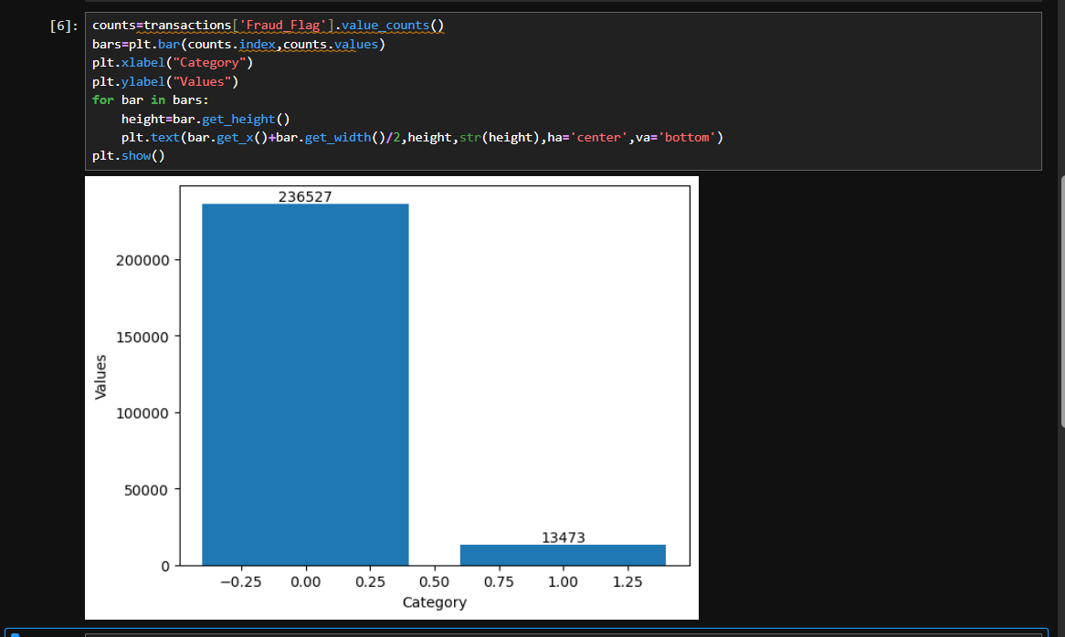
Through this we get to know that 236527 transactions(~95% transactions) were not fraudulent and remaining 13473 were detected as fraud.
And when we analyzed the fraud rate in transactions over the years we get to know that:
Transaction_year | Fraud_Flag | Fraud_Status
2023 | 0 | 67535
2023 | 1 | 3827
2024 | 0 | 55217
2024 | 1 | 3134
2025 | 0 | 61516
2025 | 1 | 3517
2026 | 0 | 52259
2026 | 1 | 2995

Through this we can get to know that 2023 holds the highest transaction rate among all completed years (excluding 2026 as it is currently running year).
We could see the highest fraud rate in same year. Also the fraud rate have reduced slightly in next year (2024) and got increased again slightly in following year (2025).
I have specifically analyzed the transaction channels were fraudulent have occurred and it was found that POS (point of sale) the place where people pay the amount through physical card have recorded the highest fraudulent rate among all where initially it was said that online transactions were reason for cause. But it was proven wrong and have been said that Physical transaction is the core reason for cause.
Transaction_Channel | Transaction_count
POS | 6367
Mobile App | 3613
ATM | 2122
Online Web | 1371

It was confirmed that transactions were happened through credit and debit cards.
When we analyzed for the transaction amount that have been lost by users due to fraud is 1052.2 Crores amount have been lost in fraudulent events which is a concerning one.

When we looked for the reasons mentioned in fraud transactions we have got a list as:
- High Risk Merchant Category Spike
- Late Night Geographical & Velocity Anomaly
- None
- Rapid Velocity & Multiple Failed Auth Attempts
- Transaction Attempt on Blocked Card
- Transaction Attempt on Expired Card
- Transaction Attempt on Lost Card
- Unusual Cross-Border / International Transaction
- Unusual High Transaction Amount vs Credit Limit
Except “None”, if we have any of above reasons the transactions will be flagged under fraud category.
Out of 250000 transactions, 2277821 were successful and 22179 were failed transactions.
When we recorded the transactions_channel medium when we noticed the failed transactions we come to know that POS has most in the count of 4915 failed transactions in its list.
Transaction_Channel | Used_count
POS | 4915
Mobile App | 2634
ATM | 1572
Online Web | 1048

Since, we don’t have a valid reason recorded for the failed transactions there is no point in assuming the data on our own as it could lead to the discrepancy in analysis.

When we looked for the transactions that have been occurred between nations and with a case of only successful transactions we have get to know that 10654 transactions have been happened and were successful.
I had a planned to investigate about the international transactions that have been occurred, so when I checked for the detail I could able to see both customer and location address shows India.
Since, we don’t have the currency type details with us, it lead to a quite confusion with us.
So, we have opted to check for the card details there also we could see all type of cards_network (American_Express, Visa, Master_Card and Rupay), we couldn’t able to come to a clear conclusion.
So when we discussed regarding this with the concerned team we get to know that the data was mapped wrongly due to improper logic created by their team to collect the transactions.
The criteria was given to us to consider the case in following circumstance:
- If the card Network is in any of this {“American_Express”,”Visa”} and it was already mapped(is_international=1) then consider it as international transaction else Domestic Transaction.
So, subject to this requirement we have created a new column named (Domestic/International) which will be utilized for our analysis case.

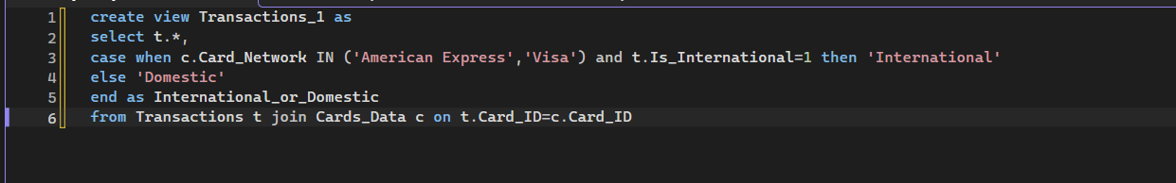

So, transactions_1 table would contain the revised details in it, which will useful for the better understanding in the data.

When we analyzed the data as per our revised condition, we could able to see that 5355 international transactions have been occurred within this years(2023-2026) and the transactions went successful out of 6320 total transactions. And around 24.52 crore was handled in total out of which Rs. 15.22 crore have been transferred successfully from customers to merchants.
Customer_State | Transaction_amount | Rank
Kerala | 302784240.33 | 1
Odisha | 281082081.22 | 2
Uttar Pradesh | 280863020.7 | 3
Karnataka | 280800216.57 | 4
West Bengal | 280060017.73 | 5
Haryana | 278160233.57 | 6
Punjab | 277990390.74 | 7
Telangana | 277858413.63 | 8
Assam | 277613154.06 | 9
Rajasthan | 275273779.06 | 10
Gujarat | 274508049.93 | 11
Madhya Pradesh | 269225692.12 | 12
Bihar | 267799980.15 | 13
Maharashtra | 264318946.71 | 14
Tamil Nadu | 263543134.26 | 15
We have ranked the customer_state based on the transaction amount that have been spent and we can able to kerala is at top but economically top states like Tamil Nadu and Maharashtra were at bottom at list it is unexpected by the team when we showed the actuals to the client.
Similarly, when we calculated for earning levels by merchant with respect to state segment we get to know that:
Merchant_State | Transaction_Amount | Rank
Tamil Nadu | 424253039.32 | 1
Uttar Pradesh | 350146885.28 | 2
West Bengal | 314307636.23 | 3
Gujarat | 298907903.39 | 4
Assam | 296111215.17 | 5
Haryana | 288319565.5 | 6
Punjab | 283564511.52 | 7
Rajasthan | 278783426.71 | 8
Bihar | 276672607.57 | 9
Odisha | 253373418.86 | 10
Kerala | 240533177.35 | 11
Madhya Pradesh | 234205922.6 | 12
Telangana | 225018165.91 | 13
Karnataka | 220253574.23 | 14
Maharashtra | 167430301.13 | 15

In this we see Tamil Nadu leads the list and it leads the client to concern as Maharashtra was been in bottom even in this segment also. They were happy with the position of Tamil Nadu (Less in spending but more in earning in terms of economy) while other states have improved like Uttar Pradesh and West Bengal have been at good level though surviving through external circumstances.
Similarly, the requirement was given to find the category that contributes good level amount that strengthens the economy of the state which comes top in merchant level.
Now we have found that Tamil Nadu is that state, so lets analyze the categories that earns well
Merchant_Category | Transaction_Amount | Rank
Hospital | 624705568.33 | 1
Airline | 608330082.32 | 2
Electronics | 522327747.31 | 3
Education | 475683109.8 | 4
Hotel | 414039584.93 | 5
Financial Services | 394319079.54 | 6
Travel | 346694054.95 | 7
Fashion | 176169421.8 | 8
Ecommerce | 162879985.15 | 9
Fuel | 98989157.57 | 10
Entertainment | 78986179.93 | 11
Grocery | 71795624.39 | 12
Pharmacy | 64259344.97 | 13
Utilities | 59088711.64 | 14
Food Delivery | 53613698.15 | 15

Through this details, we can come to a conclusion that Hospital have given them a good contribution of all which denotes their Medical Facilities have been used the client’s bank as their basic transaction medium.
Merchant_Name | Transaction_Amount | Rank
Manipal Hospitals | 35153039.9573975 | 1
Apollo Hospitals | 17751987.6749268 | 2
Max Healthcare | 16223693.4465332 | 3

The Hospital listed above are the one located in Tamil Nadu and the Manipal Hospital leads the list with the highest transaction amount of 35.16 crore.

Similarly, we have done for categories as well to know the merchants who have to performed in within their category and the data that we have found is:
Merchant_Category | Merchant_Name | Transaction_Amount | Rank
Airline | IndiGo | 50629240.3867188 | 1
Airline | SpiceJet | 32778353.935791 | 2
Airline | Air India | 15457086.2885742 | 3
Ecommerce | Snapdeal | 4522754.1655426 | 1
Ecommerce | Amazon | 4332959.8039856 | 2
Education | Udemy | 16637970.7763672 | 1
Education | Coursera | 16585224.1318359 | 2
Electronics | Vijay Sales | 35507477.4663086 | 1
Electronics | Samsung SmartCafe | 33509433.0087891 | 2
Entertainment | BookMyShow | 3313606.40182495 | 1
Entertainment | Netflix India | 1032482.29252625 | 2
Fashion | Zara India | 9837226.91912842 | 1
Financial Services | Cashfree | 14545522.4274902 | 1
Financial Services | Razorpay | 13912997.3310547 | 2
Financial Services | Paytm | 10668249.7354736 | 3
Food Delivery | Domino's India | 5423375.00563812 | 1
Food Delivery | Swiggy | 1954171.09486389 | 2
Food Delivery | Zomato | 848631.116699219 | 3
Fuel | Jio-bp | 2752485.2996521 | 1
Fuel | HP Lubricants | 2724775.22369385 | 2
Fuel | Indian Oil | 2374479.70904541 | 3
Grocery | Reliance Smart | 1451659.36761475 | 1
Grocery | Instamart | 1378271.15003967 | 2
Hospital | Manipal Hospitals | 35153039.9573975 | 1
Hospital | Apollo Hospitals | 17751987.6749268 | 2
Hospital | Max Healthcare | 16223693.4465332 | 3
Hotel | Taj Hotels | 18053359.2681885 | 1
Hotel | OYO Rooms | 7947564.8203125 | 2
Pharmacy | Tata 1mg | 1132427.29528046 | 1
Pharmacy | Wellness Forever | 1039368.78924561 | 2
Travel | Uber India | 17398271.0993042 | 1
Travel | Goibibo | 10196281.5805664 | 2
Travel | IRCTC | 9850983.39929199 | 3
Travel | Yatra | 7327628.94580078 | 4

Year | Avg_Spending_Power
2023 | $₹$16377.8033752925
2024 | ₹16793.9454474272
2025 | $₹$16559.8066063891
These are the details that we have found in merchants earning in the state Tamil Nadu.
Lets focus on the average spending power in last 3 years (2023-2025).
we could see average spending was in between ₹1600-₹1660.
When we similar analysis in state wise we could see
Year | Customer_State | Avg_Spending_Power
2023 | Assam | 16962.11
2023 | Bihar | 16811.61
2023 | Gujarat | 16436.2
2023 | Haryana | 17271.09
2023 | Karnataka | 15913.03
2023 | Kerala | 16988.07
2023 | Madhya Pradesh | 16543.21
2023 | Maharashtra | 15392.48
2023 | Odisha | 16800.26
2023 | Punjab | 16789.74
2023 | Rajasthan | 15416.6
2023 | Tamil Nadu | 14244.41
2023 | Telangana | 15999.53
2023 | Uttar Pradesh | 16697
2023 | West Bengal | 17248.38
2024 | Assam | 16413.55
2024 | Bihar | 16783.7
2024 | Gujarat | 16350.37
2024 | Haryana | 17228.78
2024 | Karnataka | 15803.58
2024 | Kerala | 18544.96
2024 | Madhya Pradesh | 16547.98
2024 | Maharashtra | 17041.41
2024 | Odisha | 16528.3
2024 | Punjab | 16559.56
2024 | Rajasthan | 18438.08
2024 | Tamil Nadu | 16906.86
2024 | Telangana | 17365.91
2024 | Uttar Pradesh | 16196.44
2024 | West Bengal | 15239.72
2025 | Assam | 16697.44
2025 | Bihar | 15674.84
2025 | Gujarat | 15762.39
2025 | Haryana | 15342.71
2025 | Karnataka | 17660.06
2025 | Kerala | 17001.18
2025 | Madhya Pradesh | 15587.8
2025 | Maharashtra | 15975.14
2025 | Odisha | 17689.29
2025 | Punjab | 16569.23
2025 | Rajasthan | 17145.05
2025 | Tamil Nadu | 16960.13
2025 | Telangana | 17005.42
2025 | Uttar Pradesh | 16779.56
2025 | West Bengal | 16426.66

We could witness the range is between ₹15k-₹17k when compared across all the state.
Additionally, we had a request to know the average amount that have been lost in frauds across state over the years and we have got the list as below:
Year | Customer_State | Avg_Loss_fraud
2023 | Assam | 81650.92
2023 | Bihar | 66759.83
2023 | Gujarat | 80142.37
2023 | Haryana | 88005.91
2023 | Karnataka | 63588.12
2023 | Kerala | 80970.24
2023 | Madhya Pradesh | 75198.64
2023 | Maharashtra | 56189.26
2023 | Odisha | 73517.55
2023 | Punjab | 81137.78
2023 | Rajasthan | 73484.32
2023 | Tamil Nadu | 46288.13
2023 | Telangana | 60055.13
2023 | Uttar Pradesh | 70399.86
2023 | West Bengal | 92723.92
2024 | Assam | 81352.44
2024 | Bihar | 84623.71
2024 | Gujarat | 70942
2024 | Haryana | 83177.13
2024 | Karnataka | 72901.36
2024 | Kerala | 108247.98
2024 | Madhya Pradesh | 81134.79
2024 | Maharashtra | 93840.08
2024 | Odisha | 89405.36
2024 | Punjab | 84433.91
2024 | Rajasthan | 90223.51
2024 | Tamil Nadu | 84982.84
2024 | Telangana | 76066.78
2024 | Uttar Pradesh | 61412.43
2024 | West Bengal | 62428.48
2025 | Assam | 84887.75
2025 | Bihar | 71920.71
2025 | Gujarat | 65185.88
2025 | Haryana | 58952.68
2025 | Karnataka | 102657.48
2025 | Kerala | 95428.09
2025 | Madhya Pradesh | 72741.03
2025 | Maharashtra | 71536.33
2025 | Odisha | 96977.35
2025 | Punjab | 83173.33
2025 | Rajasthan | 100652.14
2025 | Tamil Nadu | 71318.21
2025 | Telangana | 75277.29
2025 | Uttar Pradesh | 75739.83
2025 | West Bengal | 66823.52

We have analyzed the fraud transaction happened(under the condition only if transaction status was successful) in the data given over the years and we have listed them here as follows:

Year | Fraud_count
2023 | 872
2024 | 753
2025 | 833
2026 | 689

And we analyzed the count in state wise over the years and we have got the data as:
Year | Customer_State | Fraud_count
2023 | Karnataka | 74
2023 | Madhya Pradesh | 67
2023 | Punjab | 65
2023 | Maharashtra | 63
2023 | Assam | 63
2023 | Uttar Pradesh | 61
2023 | Telangana | 61
2023 | Odisha | 60
2023 | Haryana | 56
2023 | Bihar | 55
2023 | West Bengal | 54
2023 | Kerala | 54
2023 | Gujarat | 50
2023 | Rajasthan | 45
2023 | Tamil Nadu | 44
2024 | Gujarat | 62
2024 | Kerala | 61
2024 | Uttar Pradesh | 56
2024 | Rajasthan | 56
2024 | West Bengal | 55
2024 | Karnataka | 55
2024 | Maharashtra | 52
2024 | Haryana | 51
2024 | Assam | 51
2024 | Punjab | 48
2024 | Telangana | 48
2024 | Bihar | 48
2024 | Odisha | 44
2024 | Madhya Pradesh | 34
2024 | Tamil Nadu | 32
2025 | Haryana | 68
2025 | Odisha | 65
2025 | Karnataka | 63
2025 | Uttar Pradesh | 62
2025 | Kerala | 59
2025 | Maharashtra | 58
2025 | Madhya Pradesh | 57
2025 | West Bengal | 55
2025 | Punjab | 54
2025 | Telangana | 53
2025 | Rajasthan | 50
2025 | Bihar | 48
2025 | Assam | 48
2025 | Tamil Nadu | 47
2025 | Gujarat | 46
2026 | Gujarat | 59
2026 | Kerala | 55
2026 | Haryana | 53
2026 | West Bengal | 52
2026 | Madhya Pradesh | 51
2026 | Punjab | 47
2026 | Assam | 46
2026 | Rajasthan | 45
2026 | Bihar | 43
2026 | Telangana | 43
2026 | Tamil Nadu | 41
2026 | Uttar Pradesh | 41
2026 | Odisha | 39
2026 | Maharashtra | 38
2026 | Karnataka | 36
through this we can get to know that in Karnataka(2023), Gujarat(2024 & 2026) and Haryana(2025) leads the list in most number of transactions in terms of customers (to the state which they belong to). We may consider in the case that these people require more awareness sessions required to overcome this kind of events.

Similarly we calculated the count of frauds occurred in states in terms of merchant_state (who initiated the scam) where listed as:
Year | Merchant_State | Fraud_count | Rank
2023 | Gujarat | 85 | 1
2023 | Tamil Nadu | 84 | 2
2023 | Assam | 66 | 3
2023 | Haryana | 64 | 4
2023 | Bihar | 64 | 5
2023 | Rajasthan | 63 | 6
2023 | West Bengal | 61 | 7
2023 | Punjab | 61 | 8
2023 | Odisha | 57 | 9
2023 | Uttar Pradesh | 50 | 10
2023 | Madhya Pradesh | 49 | 11
2023 | Telangana | 45 | 12
2023 | Maharashtra | 44 | 13
2023 | Kerala | 42 | 14
2023 | Karnataka | 37 | 15
2024 | Tamil Nadu | 72 | 1
2024 | Punjab | 63 | 2
2024 | Bihar | 59 | 3
2024 | Assam | 57 | 4
2024 | Karnataka | 52 | 5
2024 | West Bengal | 52 | 6
2024 | Gujarat | 50 | 7
2024 | Uttar Pradesh | 49 | 8
2024 | Madhya Pradesh | 48 | 9
2024 | Rajasthan | 46 | 10
2024 | Odisha | 46 | 11
2024 | Kerala | 44 | 12
2024 | Haryana | 43 | 13
2024 | Maharashtra | 37 | 14
2024 | Telangana | 35 | 15
2025 | Tamil Nadu | 75 | 1
2025 | Gujarat | 71 | 2
2025 | Uttar Pradesh | 69 | 3
2025 | Assam | 68 | 4
2025 | Bihar | 67 | 5
2025 | Haryana | 58 | 6
2025 | Punjab | 55 | 7
2025 | West Bengal | 52 | 8
2025 | Madhya Pradesh | 50 | 9
2025 | Kerala | 49 | 10
2025 | Karnataka | 49 | 11
2025 | Odisha | 48 | 12
2025 | Maharashtra | 46 | 13
2025 | Rajasthan | 42 | 14
2025 | Telangana | 34 | 15
2026 | Gujarat | 69 | 1
2026 | Tamil Nadu | 67 | 2
2026 | Bihar | 67 | 3
2026 | Assam | 53 | 4
2026 | West Bengal | 52 | 5
2026 | Punjab | 49 | 6
2026 | Haryana | 49 | 7
2026 | Rajasthan | 47 | 8
2026 | Uttar Pradesh | 41 | 9
2026 | Odisha | 39 | 10
2026 | Maharashtra | 38 | 11
2026 | Madhya Pradesh | 37 | 12
2026 | Telangana | 30 | 13
2026 | Kerala | 27 | 14
2026 | Karnataka | 24 | 15
In merchants level, we see that Gujarat(2023 and 2026) and Tamil Nadu(2024 and 2025) leads the list, in terms of merchant. We can reason it as fraudsters exist in this states more and mainly them do this circumstances typically to other state people.
As when we compare the data of frauds between customers and merchants both were varied which mean that the own state people(Customers of Gujarat and Tamil Nadu) experienced less frauds they were some how middle I the list.
But the merchants of the same state shown their tricks in frauds especially when the customer is from other state.

Lets analyze the merchant categories who involves in such cases:
Merchant_state | Merchant_Category | Fraud_count | Rank
Gujarat | Fuel | 41 | 1
Gujarat | Fashion | 30 | 2
Gujarat | Ecommerce | 28 | 3
Gujarat | Entertainment | 23 | 4
Gujarat | Education | 22 | 5
Gujarat | Food Delivery | 18 | 6
Gujarat | Hospital | 17 | 7
Gujarat | Hotel | 15 | 8
Gujarat | Grocery | 15 | 9
Gujarat | Travel | 14 | 10
Gujarat | Airline | 13 | 11
Gujarat | Pharmacy | 11 | 12
Gujarat | Utilities | 11 | 13
Gujarat | Financial Services | 9 | 14
Gujarat | Electronics | 8 | 15
Tamil Nadu | Airline | 44 | 1
Tamil Nadu | Travel | 35 | 2
Tamil Nadu | Hospital | 31 | 3
Tamil Nadu | Food Delivery | 28 | 4
Tamil Nadu | Fuel | 27 | 5
Tamil Nadu | Electronics | 22 | 6
Tamil Nadu | Hotel | 18 | 7
Tamil Nadu | Fashion | 16 | 8
Tamil Nadu | Education | 15 | 9
Tamil Nadu | Entertainment | 14 | 10
Tamil Nadu | Pharmacy | 14 | 11
Tamil Nadu | Grocery | 13 | 12
Tamil Nadu | Financial Services | 11 | 13
Tamil Nadu | Ecommerce | 10 | 14

This was the list that we have got and we could see the contrast in the list but we see contrast in both the categories as we see in Gujarat Fuel, Fashion, Ecommerce entertains the fraud whereas in Tamil Nadu Airline, Travel and Hospital categories have entertained the scams.

While seeing the Tamil Nadu’s Data we could come to the conclusion that other state people have been fallen in victim situation as these three sectors clearly makes picture.
But in Gujarat, we see the fraud have been happened especially in online platforms.
These data will give the customer to necessary action from their side and could start the awareness initiative based on the data we have given, so they proceed with these ordering and the mentioned categories.

Since the main aspect of data given by the client is to make them aware of this information and to make sure no issue in future we have created a ML model to them which helps them to safeguard their customers.
At first I have looked out for the input features for the model. I am aware that the input should not be look like a unique feature and should not lead to data leakage.
Considering these situations I have considered the features are Payment Method, Transaction_Channel, Device_Type, Transaction_Status, International_or_Domestic, Merchant_Risk_Level. In this, International or Domestic is a column created based on the existing features using the card type and currency type(Feature Engineering). Fraud Flag is the output that we have considered.
Since the output is non numeric type, so I have taken out LinearRegression in consideration. When I looked at the input features, it dint looked like categorical so I have excluded DecisionTree and RandomForest, so I have considered LogisticRegression for the calculation.
To convert the non numerical types, I have used one hot encoding technique to convert them to the numeric type and dropped one of its column for the better evaluation, since our dataset is large for cross validation we have used StartifiedKFold for validation.
Considering all these factors we have created the model and it scored a value of 95.56%.
Similarly, we have done the testing for overfitting or underfitting an we got that model scored very close in training as well as testing, Hence, we have deployed this model to the client for their future purpose.
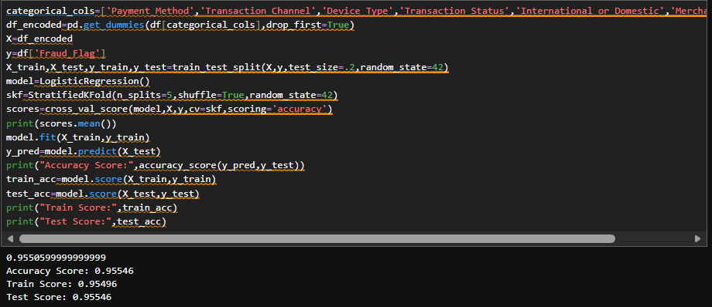
Hence, the final part that is pending on this project is creating Interactive Dashboard for the client’s usage (i.e.,) a PBI report.

The PBI report work has been completed and listed out the documented work for reference.
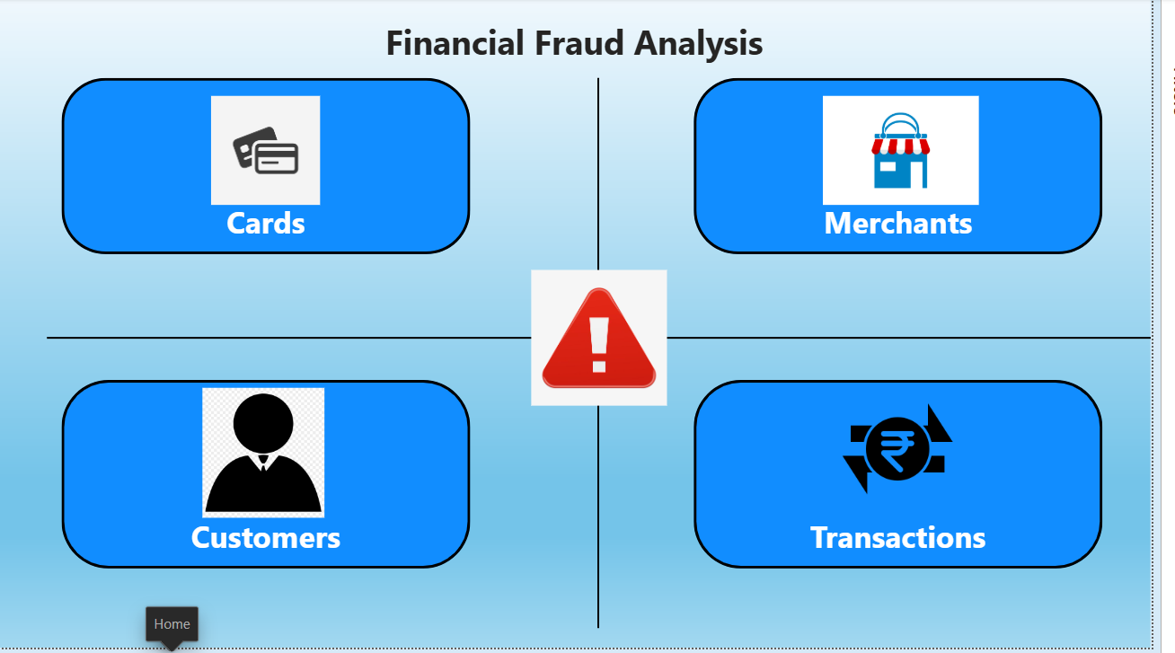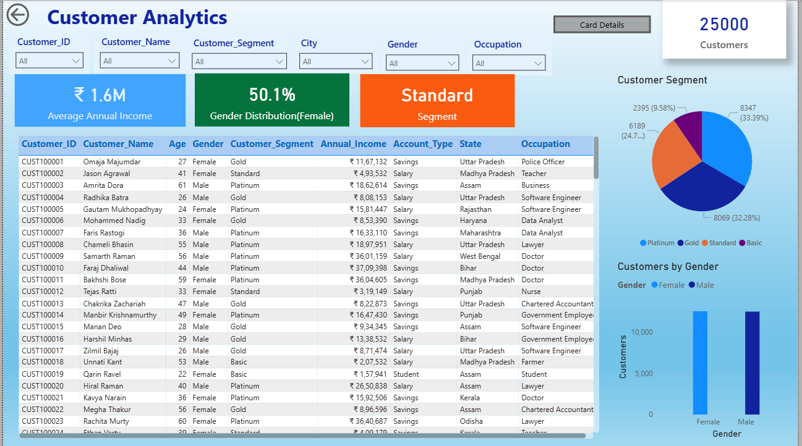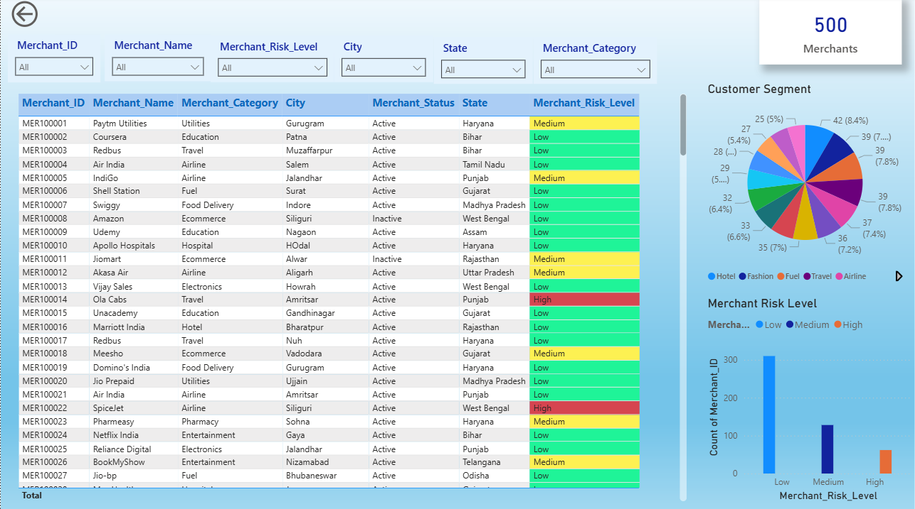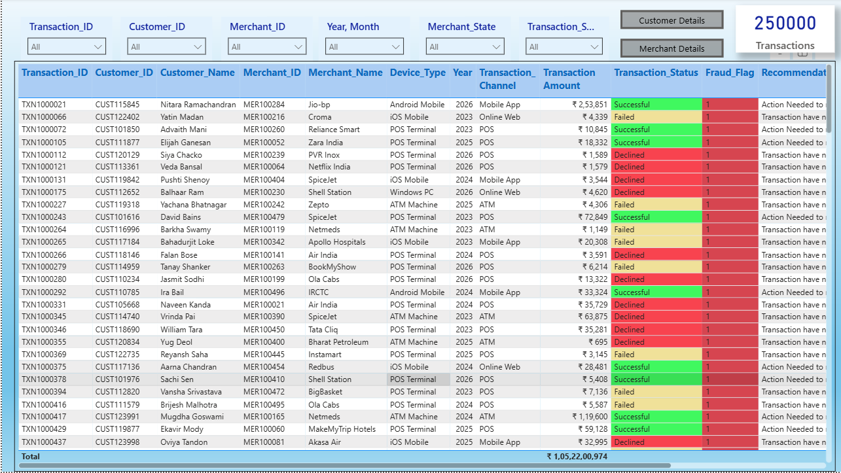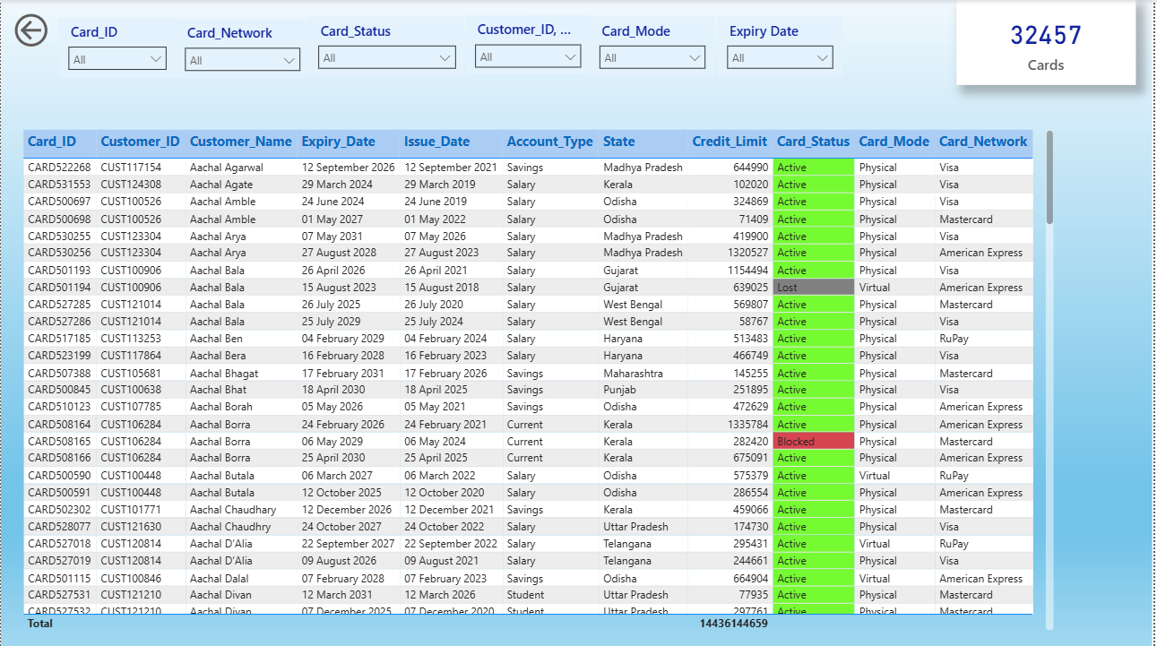
With this, the project is completed we would work in future if new data or insight could be collected.

